SQL – Project 1

**Data Modeling**

**Trucking Company**

**Goals:**

* Draw the entity relationship diagram with the appropriate cardinality
* Add attributes to identify entities as needed (name all attributes and entities)
* Determine cardinality (1:N, N:N) and type of relationships, differentiating between "mandatory" and "optional" relationships

**Recall:**

General meanings:

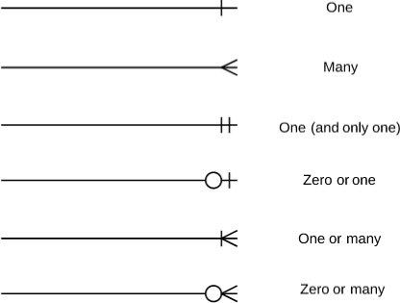

Mandatory vs. optional:



**PART A-D: TOGETHER ON THE BOARD**

**Part A**

A trucking company employs mechanics to maintain vehicles. Each mechanic is usually assigned to many vehicles, however they go on vacation sometimes and may not be assigned to vehicles for weeks at a time. A vehicle is always assigned to 1 mechanic.

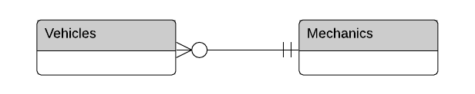

**Part B**

A trucking company has several garages. A garage may contain many bays, each garage has at least one bay. A bay must be in a garage.

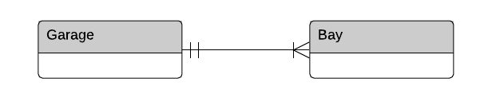

**Part C**

A garage employs managers to monitor vehicle availability and repair costs. Each manager is assigned at least 1 and usually many vehicles. A vehicle may or may not have a manager responsible.

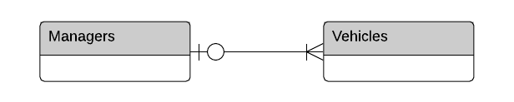

**Part D**

A garage maintains a list of specialized repair personnel who are used as necessary. A specialist may work on many vehicles, but may also have no current jobs. A vehicle may or may not be repaired by a specialist.

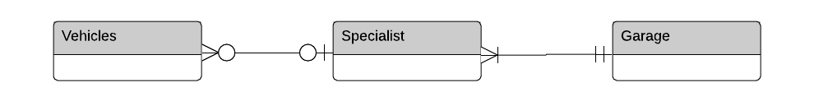

**PART E-F: AS A CLASS**

**Part E**

Put together a final diagram for this system and select and label primary and foreign keys

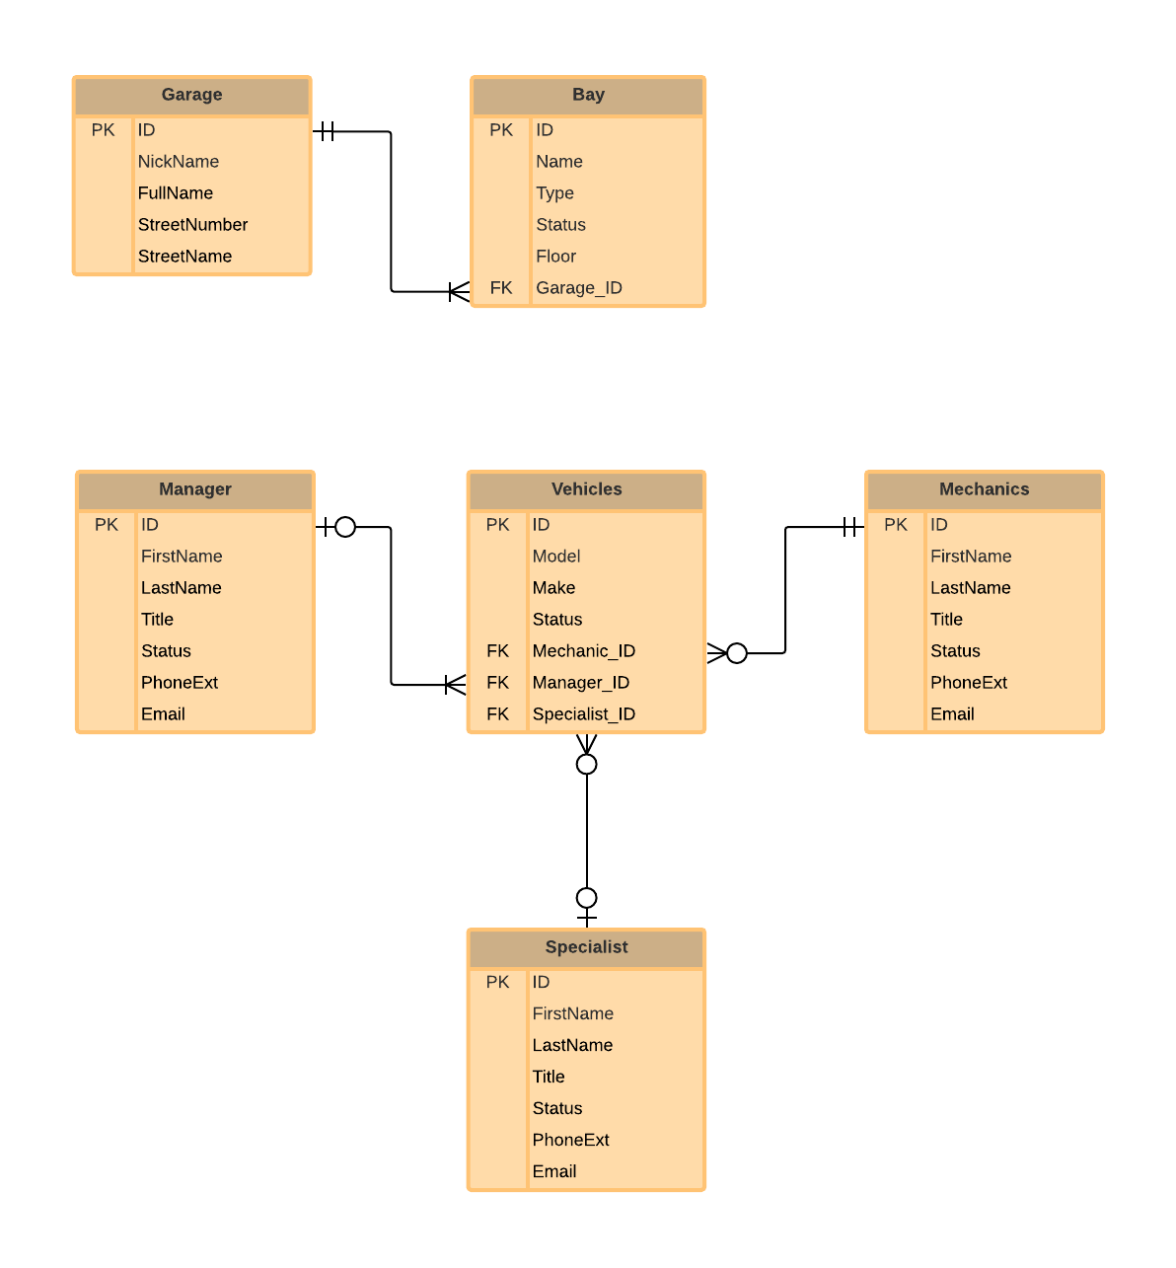

**Part F**

You should have two diagrams that are not yet linked – how do you suggest we link them? What should be the cardinality of this relationship? (Hint: Assume a garage bay only holds a single vehicle)

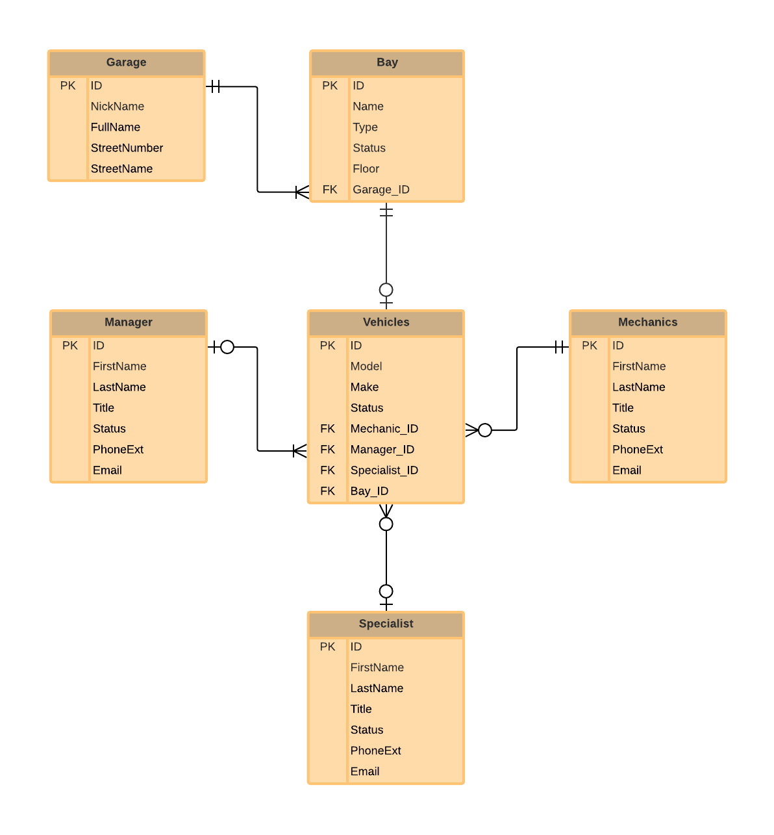

**PAUSE HERE, write a summary paragraph of your findings.**

In this trucking company, every vehicle is assigned to a mechanic for maintenance. When the vehicle needs to be repaired, there will be a specialist assigned to it. There may also be a manager assigned to it due to monitor purposes. So we use mechanic ID, specialist ID and manager ID as foreign keys to link them all. On the other hand, every vehicle also has a bay to park in the garage. So we use Bay ID to link vehicles and bay, and use garage ID to link bay and garage.